Bug Report - 06:

Cash Deposit lacks a maximum amount limit
Environment: Windows 11, Opera GX
Test Object: Cash Deposit / System Limits

Preconditions:
- The website is open
- The user is logged in to a valid account

Steps:
- Click on 'Cash Deposit'
- Enter the value 9007199254740991
- Confirm the deposit
- Click 'Cash Deposit' again and attempt to deposit another amount like 100
- Check the balance

Expected Result:
- The system should enforce a maximum deposit limit and reject overly huge numbers

Actual Result:
- The system accepts the maximum memory integer, causing subsequent arithmetic operations to fail and the balance stops updating correctly
Attachment:
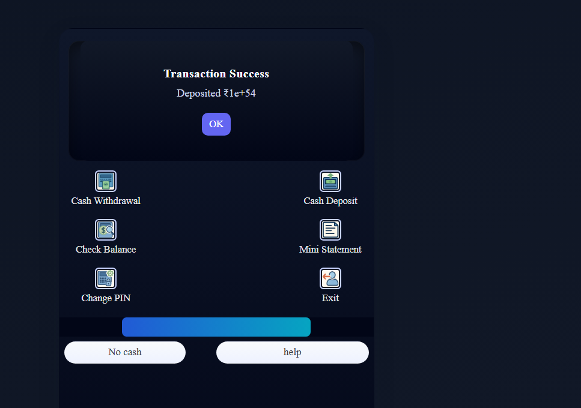
Severity: Medium
Priority: Medium

